**Assignment 1.2**

**PWD: prints the absolute path of to current working directory**

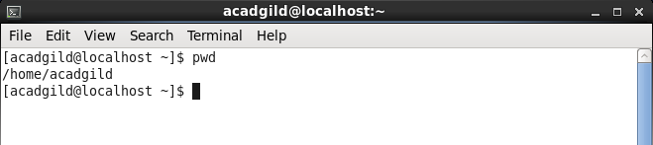

**Touch: This command is used to create files by just typing (touch <FileNameWithExtension>)**

**Created a Text file under Acadgild (SampleFile.txt)**

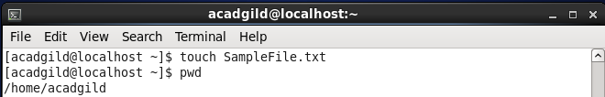

**LS: This command is used to list the files and the directories present in the current path**

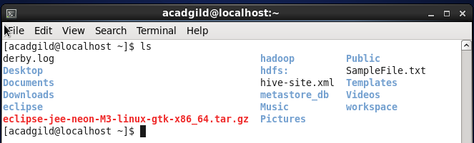

**MKDIR: This command allows the user to make a new directory.**

**Created a directory under Acadgild (testDirectory)**

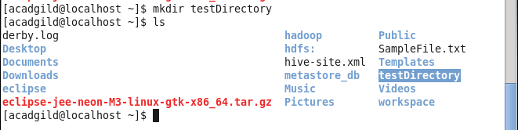

**RM: The RM command is used to remove files from the system.**

**Removed the File:SampleFile.txt**

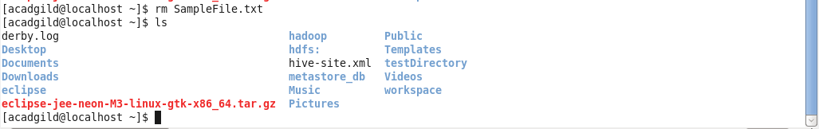

**ECHO: The ECHO command displays whatever input text is given to it.**

**We can give input text with escape sequences as well by providing ‘-e’ with echo**

**Using echo we can get the values of the variables like $HOME, $PATH.**

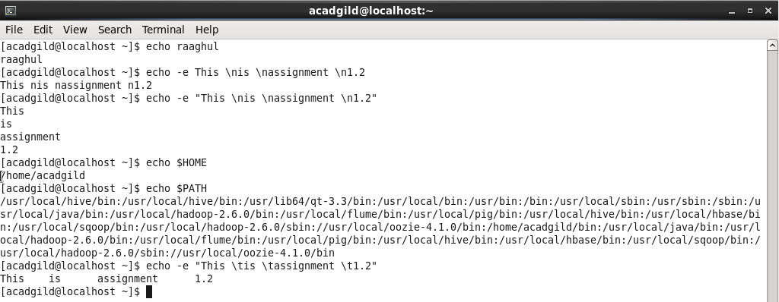

**CAT: This helps the user to view the contents present inside the file**

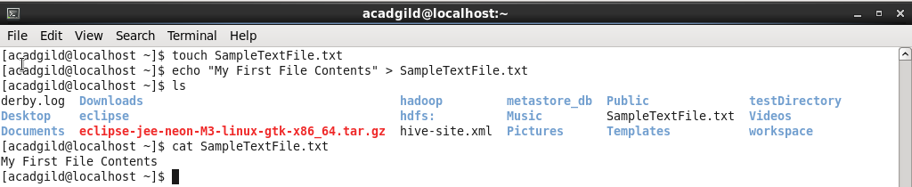

* **Will display contents of multiple files: cat [filename_1] [filename_2]**
* **Displays contents with line numbers: cat -n [filename]**

**WHO: This command shows who is logged on**

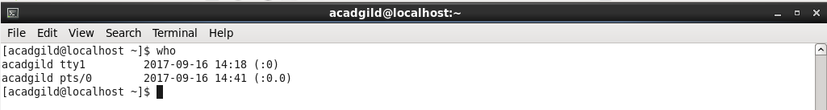

**DATE: This command is used to get the system date time.**

**And can be used to set the date as well by (date -s STRING)**

**And fetch any specific date time based on the keyed in Time Zone.**

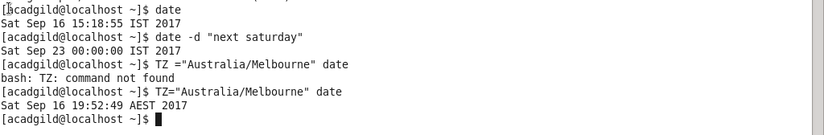

**CAL: This displays the calendar**

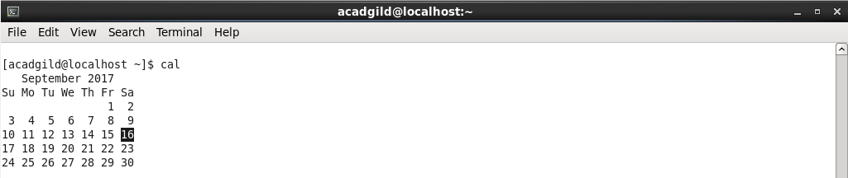

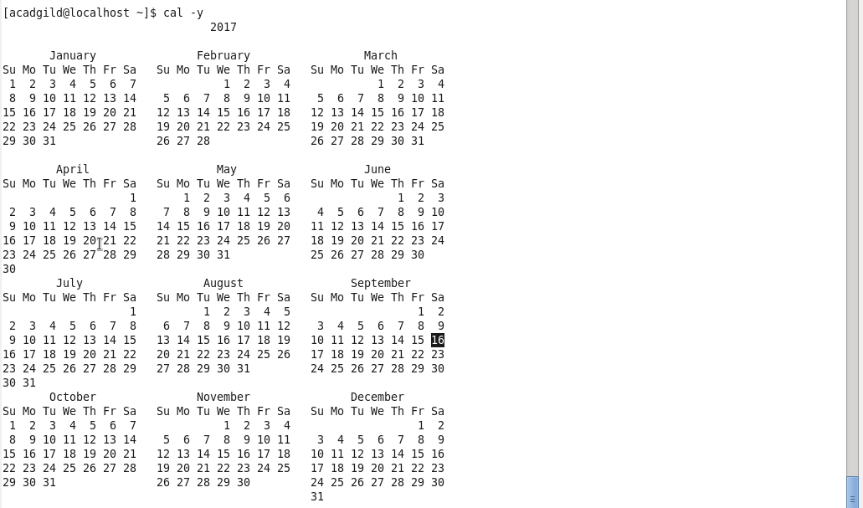

**CD: The cd command is used to change user's present working directory.**

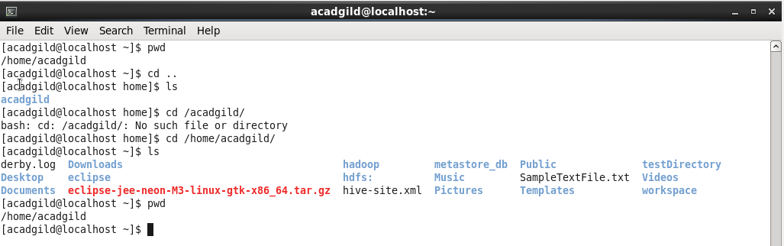

**CP: This command is used for copying files and directories**

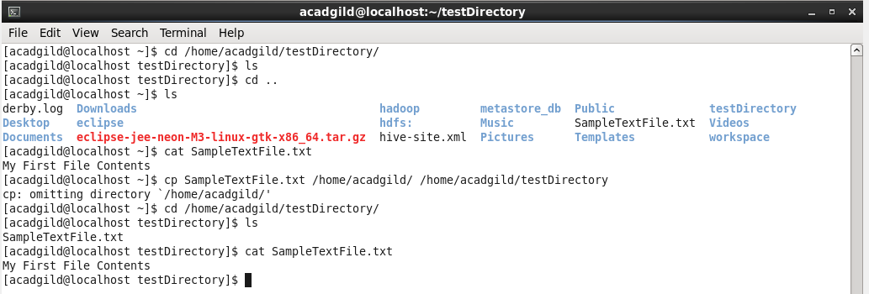

**MV: This is used to move a file from one directory to another directory.**

* **Created tempFile.txt under Acadgild**
* **Moved it to a directory (testDirectory)**
* **Now file got moved to the destination**

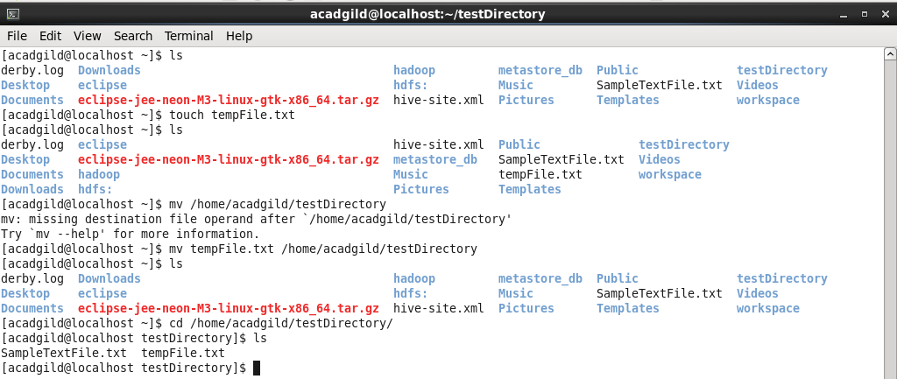

**WHICH: This command basically lets us to locate a command: the file and the path of the file that gets executed.**

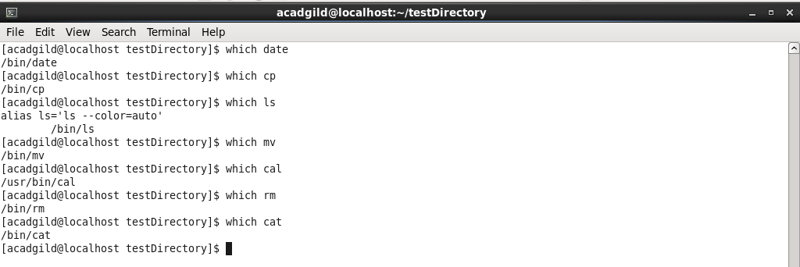

**VI: This is basically a text/programming editor**

